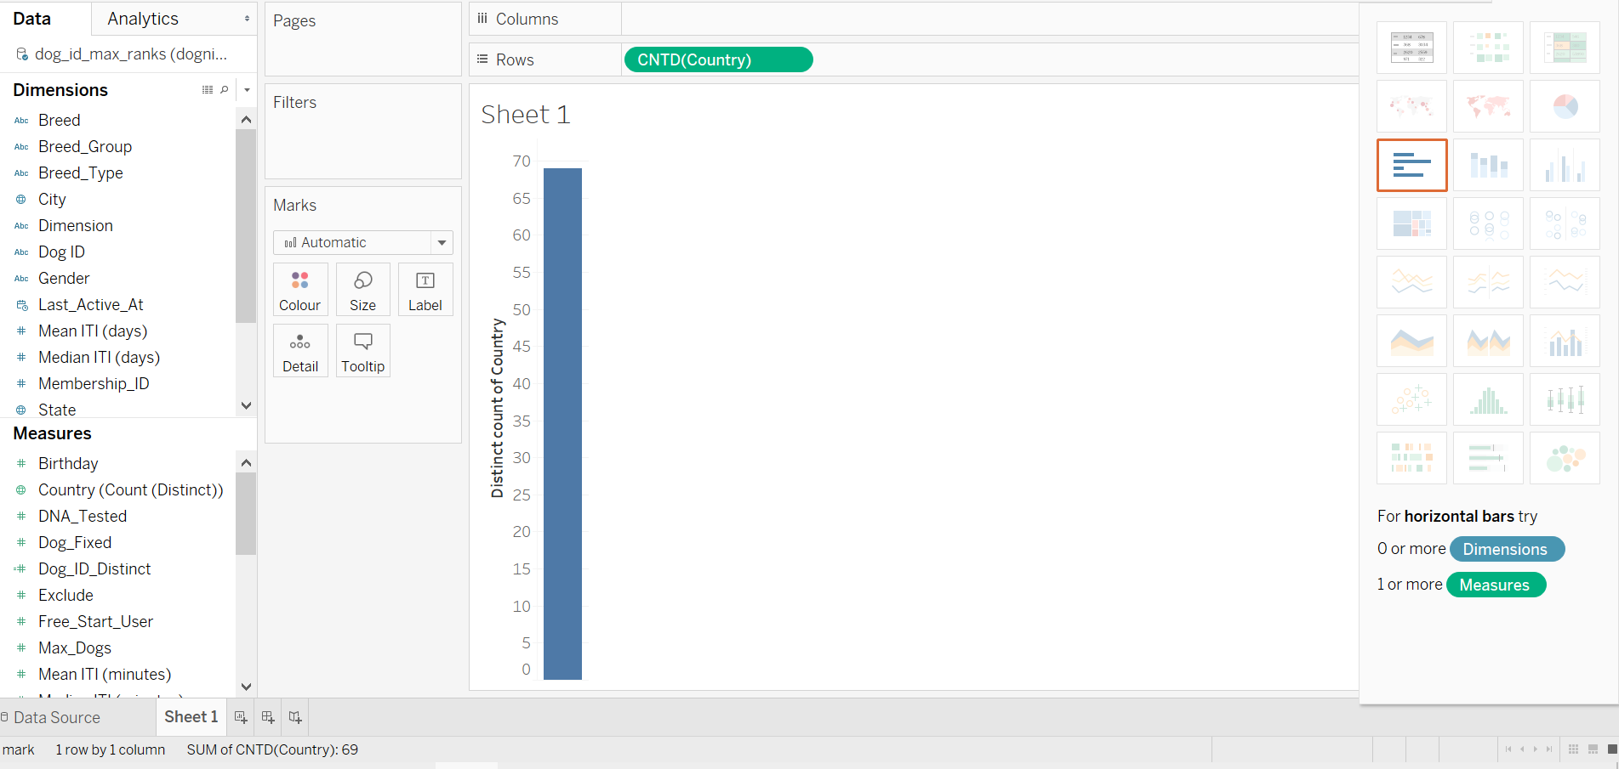  
  
  
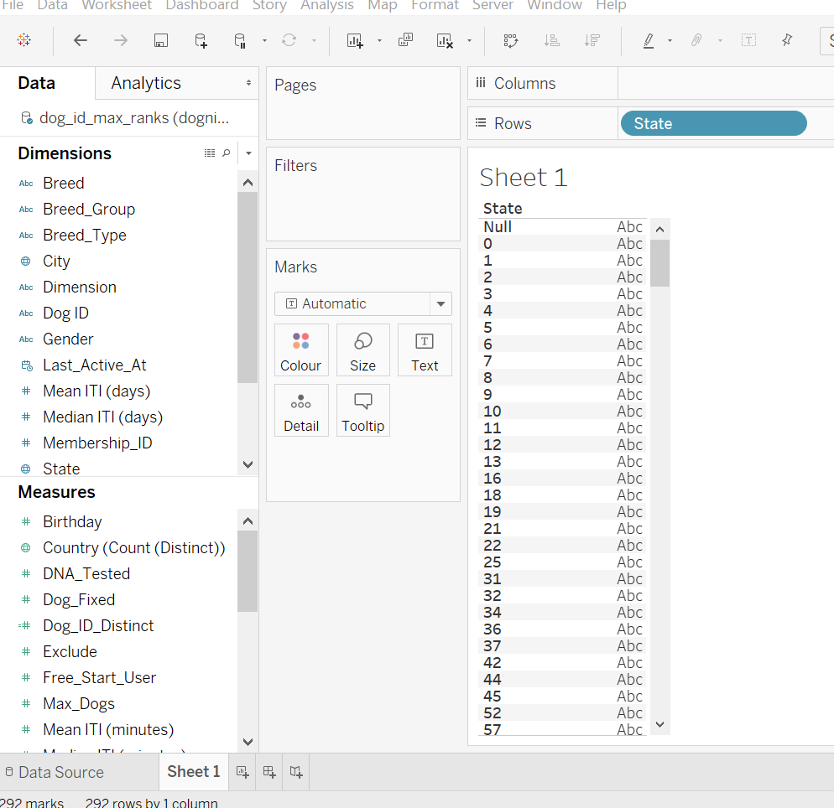  
  
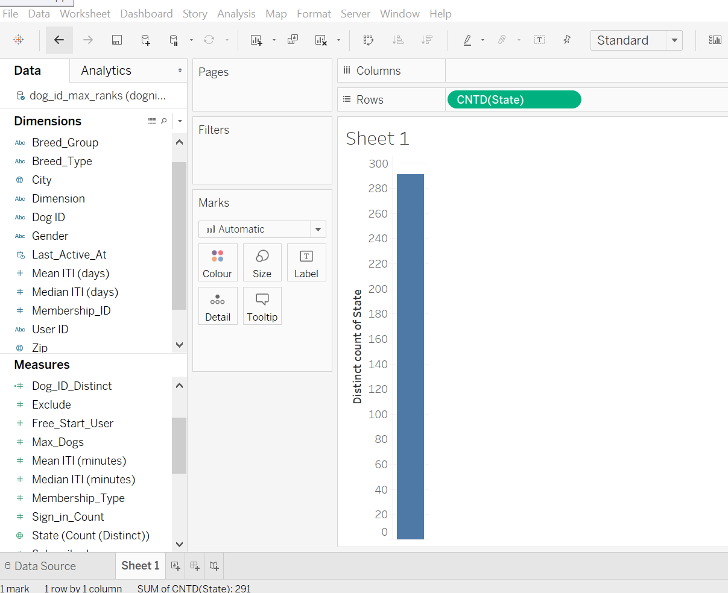

1. How many unique dogs are in the data set (indicated by the number of unique entries in Dog ID)?

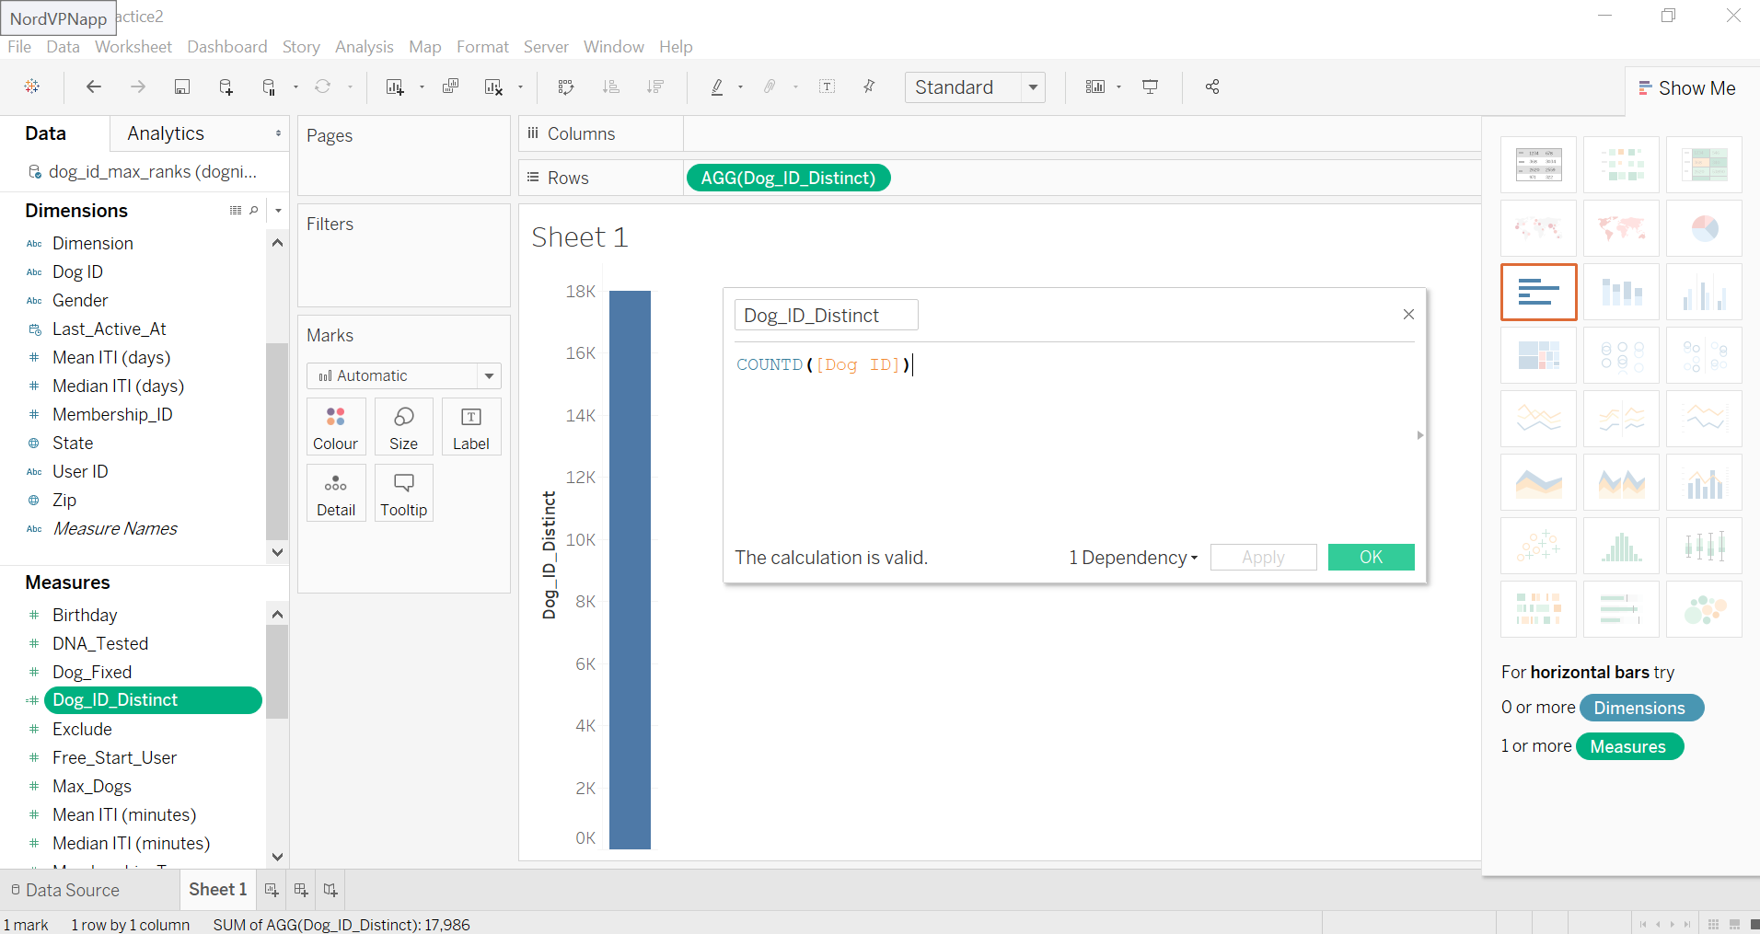

1. How many unique (human) users are in the data set (indicated by the number of unique entries in User ID)?

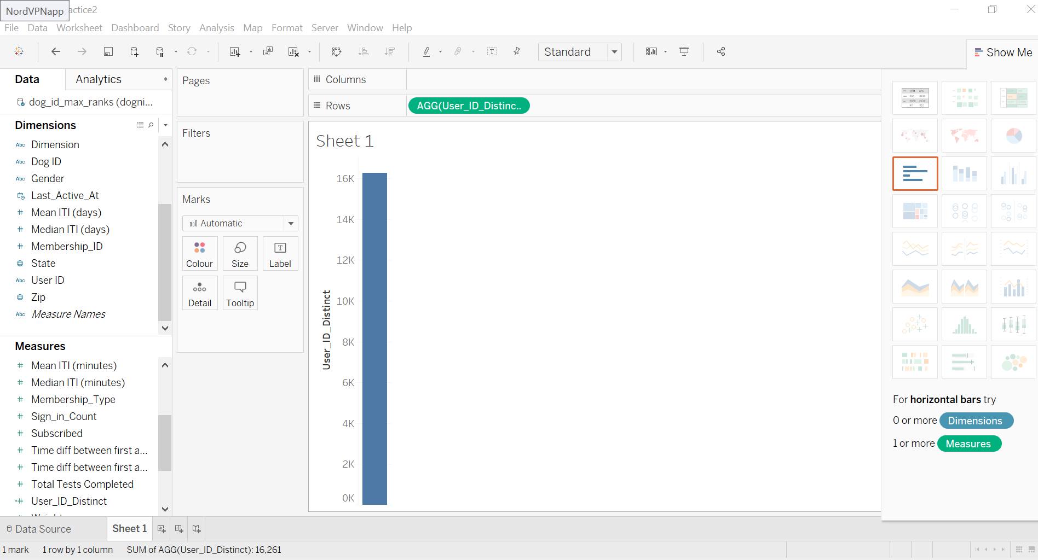

1. How many unique human user IDs are there in the Dognition_aggregated_by_DogID data set? 16261
2. What feature is common to all the rows that have a value of 37 in the “State” field of the Dognition_aggregated_by_DogID data set? Check all that apply.

(T) Estonia

(F) They are all golden retreivers

1. What property is common to almost all the data points that had “Sign In Counts” of greater than 175 in the Dognition_aggregated_by_DogID data set?

(F) They all have Dog ID fd5 blabla

1. The Personality Dimension that has the highest average number of completed tests in the Dognition_aggregated_by_DogID data set is clearly:

(F) The Renaissance Dimension

1. In the Dognition_aggregated_by_DogID data set, what is consistent about the relationship between breeding group and number of tests completed, regardless of whether you aggregate the variable representing the number of tests completed by the median or the average of the breeding group?

(T) Toy dogs complete the least number of tests

1. In the Dognition_aggregated_by_DogID data set, what personality type has the strongest representation (greatest number of records) in the sporting breed group?

(F) Protodog

1. In the Dognition_aggregated_by_DogID data set, which of the following describes the median number of tests dogs of different breed types complete?

(F) Pure-Breed dogs complete a median of 8 tests, while all the other breed typres complete a median of 7 tests

1. In the Dognition_aggregated_by_DogID data set, how do the average number of tests dogs complete compare for fixed vs. not fixed dogs across different breed types? Click all that apply



Fixed dogs complete less tests than non-fixed dogs in all breed types



Fixed dogs complete less tests than non-fixed dogs in the Cross-Breed and Mixed Breed/ I Don’t Know breed categories, but not in the other breed categories

**This should not be selected**

Please check that you are using the appropriate aggregation, and review Lesson 3 Let's Get Started and the course Practice Exercises for information about how to arrive at the correct answer.



Fixed dogs complete more tests than non-fixed dogs in the Cross-Breed and Mixed Breed/ I Don’t Know breed categories, but not in the other breed categories

**This should not be selected**

Please check that you are using the appropriate aggregation, and review Lesson 3 Let's Get Started and the course Practice Exercises for information about how to arrive at the correct answer.



The greatest difference between the average number of tests completed by fixed vs. non-fixed dogs occurs in the Mixed Breed/ I Don’t Know breed category



Fixed dogs complete more tests than non-fixed dogs in all breed types

1. In the Dognition_aggregated_by_DogID data set, which of the following are true about the average number of tests dogs complete when comparing DNA vs. not DNA-tested dogs who were fixed vs. not fixed across different breed types? Click all that apply.



DNA-tested dogs completed less tests than dogs that were NOT DNA tested in all categories except for the category of Popular Hybrids who were fixed



There was only one dog in the Popular Hybrid breed category who was DNA tested but not fixed



The Cross-Breed dogs that were DNA tested but NOT fixed were mostly Labrador Retriever-Golden Retriever Mixes

**Correct**

In almost all categories, DNA-tested dogs completed an average of more tests than dogs who were not DNA-tested. However, the numbers of dogs who were DNA-tested were pretty small. Do you think this information could be useful to Dognition?



The Cross-Breed dogs that were DNA tested but NOT fixed were mostly Golden Doodles

**This should not be selected**

Please review Lesson 3 Let's Get Started to review how to arrive at the correct answer.



DNA-tested dogs completed more tests than dogs that were NOT DNA tested in all categories except for the category of Popular Hybrids who were fixed

1. In the Dognition_aggregated_by_DogID data set, when you make a filled map that displays the number of unique Dog IDs in each country, there is country in Africa that has a deep color, suggesting it has a lot of users. When you hover over that country, what Country is displayed on the tool tip?

(F) NO

1. In the Dognition_aggregated_by_DogID data set, which state within the United States has the most Dognition customers?
2. In the Dognition_aggregated_by_DogID data set, which state within the United States has the most Dognition customers?

North Carolina, with New York having the second greatest number of customers

Florida, with Texas having the second greatest number of customers

(F) Texas, with California having the second greatest number of customers

North Carolina, with California having the second greatest number of customers

California, with New York having the second greatest number of customers

1. In the Dognition_aggregated_by_DogID data set, dogs in which of the following states did customers complete a median number of tests that was greater than 13? Check all that apply.



Maine (ME)



North Carolina (NC)



North Dakota (ND)

**Correct**

This is one of the states. North Dakota doesn't have a lot of customers, but the customers they did have finished a lot of tests.



South Dakota (SD)

**Correct**

This is one of the states. South Dakota doesn't have a lot of customers, but the customers they did have finished a lot of tests.



Wyoming (WY)

1. In the Dognition_aggregated_by_DogID data set, when looking at only dogs who completed **19** or less tests, which of the following is true about the relationship between inter-test intervals (ITIs) and number of tests completed? Click all that apply.



There was a significant negative (*p < .05*) correlation between median ITIs and number of tests completed



(F) There was a non-significant positive (*p > .05*) correlation between average ITIs and number of tests completed

**This should not be selected**

Refer to Lesson 6 Line Graphs and Box Plots to review how to answer this type of question.



There was a significant positive (*p < .05*) correlation between average ITIs and number of tests completed



There was a significant positive (*p < .05*) correlation between median ITIs and number of tests completed



There was a non-significant negative (*p > .05*) correlation between average ITIs and number of tests completed

1. In the Dognition_aggregated_by_DogID data set, when looking at only dogs who completed **7** or less tests, which of the following is true about the relationship between inter-test intervals (ITIs) and number of tests completed? Click all that apply



There was a non-significant positive (*p > .05*) correlation between average ITIs and number of tests completed



(F) There was a significant positive (*p < .05*) correlation between median ITIs and number of tests completed

**This should not be selected**

Refer to Lesson 6 Line Graphs and Box Plots to review how to answer this type of question.



There was a non-significant negative (*p > .05*) correlation between average ITIs and number of tests completed



There was a significant positive (*p < .05*) correlation between average ITIs and number of tests completed



There was a significant negative (*p < .05*) correlation between median ITIs and number of tests completed